  REFLECTION  “Do not let your hearts be troubled.  Trust in God still, and trust in me.  There are many rooms in my Father’s house;  If there were not I should have told you.  I am going now to prepare a place for you,  And after I have gone and prepared you a place,  I shall return to take you with me;  So that where I am you may be too.”  (John 14:1-3) |  |  | Readings  For Funeral Mass    Parishes of Portarlington & Emo
PLANNING YOUR LOVED ONE’S FUNERAL LITURGY  The Church encourages you to be as fully involved as you can in planning your loved one’s funeral liturgy. It is the final journey of your loved one. In the liturgy, we celebrate the life of faith of your loved one; we commend him or her to the Lord, we support and pray for all those who mourn, and we seek strength in the promise of the Lord that he will not forget his own. In planning the liturgy, you will need to:  - Select the readings for the funeral Mass. Depending on the circumstances, you may decide to have either one or two readings before the Gospel reading. You will find a large selection of suitable readings in this booklet. But you are free to choose others. Should you decide to have two readings before the Gospel, it is preferable to have a different reader for each.  - The Responsorial Psalm which comes between the first and second Readings is usually sung by the Choir.  - Choose or compose the general intercessions (Prayer of the Faithful), which come after the homily. In the general intercessions we pray not only for the deceased and his or her family and friends but also for all the dead and those who mourn them, and for the needs of the wider community. You will find a selection of general intercessions in this booklet. One or more family members should read the general intercessions.  - Choose family members or friends of the deceased to bring the gifts of bread and wine to the altar. You should keep in mind, though, that the presentation of the gifts is not the time to carry up personal memorabilia or symbols of the life of the deceased. The best time is at the beginning of the Mass.  - The hymns and music for the funeral mass is usually provided by the Choir. The hymns are those that are regularly sung during Sunday Mass and express our strong belief in the resurrection, which is the basis of Christian hope.    1 |  |  | For N… that Christ may have mercy on his/her soul, and grant him/her full pardon for his/her sins. Lord hear us.  For the sorrowing family, relatives and friends of N… that they may find strength and consolation in their faith and in the love and support of the community. Lord hear us.  For the family of N… that in these difficult and dark days they may be sustained by their faith, and by the knowledge that they will be reunited with N…. one day in God’s heavenly kingdom. Lord hear us.  The family and friends of N… seek comfort and consolation. Heal their pain and dispel the darkness and doubt that come from grief.  Lord hear us.  God of all consolation, help us to comfort one another in our grief, finding light in time of darkness, and faith in time of doubt. Lord hear us.  For all of us assembled here to worship in faith, that we may be gathered together again in God’s kingdom. Lord hear us.  For our deceased relatives and friends: that God may bring them into the light of his presence, and give them a share in his glory. Lord hear us.  For our deceased relatives and friends and for all who have helped us, that they may have the reward of their goodness. Lord hear us.  That God may welcome into his glory those of our family and friends who have departed this life. Lord hear us.  That God may give a place in the kingdom of heaven to all the faithful departed. Lord hear us.  Many friends and members of our families have gone before us and await the kingdom. Grant them an everlasting home with your Son.  Lord hear us.  We pray for all nurses and carers, particularly the nurses and carers who were so good to N… in the last months of his/her life. Lord hear us.  14
Reading 10  A reading from the first letter of St. John 3:1-2  Think of the love that the Father has lavished on us, by letting us be called God’s children; and that is what we are. Because the world refused to acknowledge him, therefore it does not acknowledge us. My dear people, we are already the children of God but what we are to be in the future has not yet been revealed; all we know is, that when it is revealed we shall be like him because we shall see him as he really is.  This is the word of the Lord.  Reading 11  A reading from the second letter of St. Paul to Timothy 4:6-8  I am already on the point of being sacrificed; the time of my departure has come. I have fought the good fight. I have finished the race. I have kept the faith. Henceforth there is laid up for me the crown of righteousness, which the Lord, the righteous judge, will award to me on that day, and not only to me but also to all who have loved his appearing.    This is the word of the Lord.  GOSPEL READING  Chosen by the Celebrant  PRAYER OF THE FAITHFUL  Choose five or six of the following. If you wish, compose some of your own, or adapt some of those suggested.  God is full of mercy and compassion. May He forgive N….. any sins he/she committed through human frailty. Lord hear us.  We pray for N…, and all those who also have died in Christ. May Christ now be their light, their joy, their consolation in the glory and peace of Heaven.  Lord hear us.  In baptism N… was given the pledge of eternal life. May he/she now be admitted to the company of the Saints. Lord hear us.  13 |  | Parishes of  Portarlington & Emo  READINGS FOR FUNERAL MASS  The readings are a central part of your loved one’s funeral Mass. You may choose one Old Testament and/or one New Testament reading before the Gospel reading. The Responsorial Psalm comes after the first reading and is usually sung by the Choir.  OLD TESTAMENT READINGS  Reading 1  A reading from the book of Job 19:1.23-27  Job said: ‘Ah, would that these words of mine were written down, inscribed on some monument with iron chisel and engraving tool, cut into the rock for ever.  This I know: that my Avenger lives, and he, the Last, will take his stand on earth. After my awaking, he will set me close to him, and from my flesh I shall look on God. He whom I shall see will take my part: these eyes will gaze on him and find him not aloof.’  This is the word of the Lord.  Reading 2  A reading from the book of Ecclesiastics 44:1-6, 10  Let us praise illustrious people, our ancestors in their successive generations. The Lord has created an abundance of glory and displayed his greatness from earliest times. Some wielded authority as kings and were renowned for their strength; others were intelligent advisers and uttered prophetic oracles. Others directed the people by their advice, by their understanding of the popular mind, and by the wise words of their teaching; others composed musical melodies, and set down ballads; others were rich and powerful, living peacefully in their homes. But here is a list of generous people whose good works have not been forgotten.  This is the word of the Lord.  2
Reading 3  A reading from the book of Wisdom 3:1-9  The souls of the virtuous are in the hands of God, no torment shall ever touch them. In the eyes of the unwise, they did appear to die, their going looked like a disaster, their leaving us, like annihilation; But they are in peace.  If they experienced punishment as men see it, their hope was rich with immortality; slight was their affliction, great will their blessing be. God has put them to the test and proved them worthy to be with him; he has tested them like gold in a furnace, and accepted them as a holocaust. When the times comes for his visitation they will shine out; as sparks run through the stubble, so will they.  They shall judge nations, rule over peoples, and the Lord will be their king forever. They who trust in him will understand the truth, those who are faithful will live with him in love; for grace and mercy await those he has chosen.  This is the word of the Lord.  Reading 4  A reading from the prophet Isaiah 41:10, 44:22, 49:15-16  Fear not, I am with you; be not dismayed; I am your God.  I will strengthen you and help you, and uphold you with my right hand of justice. For I am the Lord, your God, who grasps your right hand; it is I who say to you, ‘Fear not, I will help you.” I have brushed away your offences like a cloud, your sins like a mist; return to me, for I have redeemed you.  Can a mother forget her infant, be without tenderness for the child within her womb? Even should she forget, I will never forget you. See, upon the palm of my hand I have written your name. Yes, in joy you shall depart, in peace you shall be brought back.  This is the word of the Lord.  3 |  | Reading 7  A reading from the second letter of St. Paul to the Corinthians 5:1.6-10  We know that when the tent that we live in on earth is folded up, there is a house built by God for us, an everlasting home not made by human hands, in the heavens. We are always full of confidence, then, when we remember that to live in the body means to be exiled from the Lord, going as we do by faith and not by sight – we are full of confidence, I say, and actually want to be exiled from the body and make our home with the Lord. Whether we are living in the body or exiled from it, we are intent on pleasing him. For all the truth about us will be brought out in the law court of Christ, and each of us will get what he deserves for the things he did in the body, good or bad.  This is the word of the Lord.  Reading 8  A reading from the letter of St. Paul to the Philippians 3:20-21  For us, our homeland is in heaven, and from heaven comes the saviour we are waiting for, the Lord Jesus Christ, and he will transfigure these wretched bodies of ours into copies of his glorious body. He will do that by the same power with which he can subdue the whole universe.  This is the word of the Lord  Reading 9  A reading from the first letter of St. Paul to the Thessalonians 4:13-18  We want you to be quite certain, brothers, about those who have died, to make sure that you do not grieve about them, like the other people who have no hope. We believe that Jesus died and rose again, and that it will be the same for those who have died in Jesus: God will bring them with him. We can tell you this from the Lord’s own teaching, that any of us who are left alive until the Lord’s coming will not have any advantage over those who have died. At the trumpet of God, the voice of the archangel will call out the command and the Lord himself will come down from heaven; those who have died in Christ will be the first to rise, and then those of us who are still alive will be taken up in the clouds, together with them, to meet the Lord in the air. So we shall stay with the Lord for ever. With such thoughts as these you should comfort one another.  This is the word of the Lord  12
Reading 5  A reading from the first letter of St. Paul to the Corinthians 15:20-28  Christ has been raised from the dead, the first-fruits of all who have fallen asleep. Death came through one man and in the same way the resurrection of the dead has come through one man. Just as all men die in Adam, so all men will be brought to life in Christ; but all of them in their proper order; Christ as the first-fruits and then, after the coming of Christ, those who belong to him. After that will come the end, when he hands over the kingdom to God the Father. For he must be king until he has put all his enemies under his feet and the last of the enemies to be destroyed is death, for everything is to be put under his feet. Though when it is said that everything is subjected, this clearly cannot include the One who subjected to him, then the Son himself will be subject in his turn to the One who subjected all things to him, so that God may be all in all.  This is the word of the Lord.  Reading 6  A reading from the first letter of St. Paul to the Corinthians 15:51-57  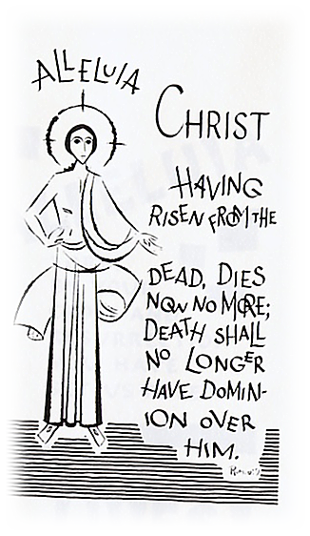  I will tell you something that has been secret; that we are not all going to die, but we shall all be changed. This will be instantaneous, in the twinkling of an eye, when the last trumpet sounds. It will sound, and the dead will be raised, imperishable, and we shall be changed as well, because our present perishable nature must put on imperishability and this mortal nature must put on immortality. When this perishable nature has put on imperishability, and when this mortal nature has put on immortality, then the words of scriptures will come true: Death is swallowed up in victory? Death, where is your sting? Now the sting of death is sin, and sin gets its power from the Law. So let us thank God for giving us the victory through our Lord Jesus Christ.  This is the word of the Lord.  11 |  | Reading 5  A reading from the book of Wisdom 4:7-15  The virtuous man, though he die before his time, will find rest. Length of days is not what makes age honourable, nor number of years the true measure of life; understanding, this is man’s grey hairs, untarnished life, this is ripe old age.  He has sought to please God, so God has loved him; as he was living among sinners, he has been taken up. He has been carried off so that evil may not warp his understanding or treachery seduce his soul; for the fascination of evil throws good things into the shade, and the whirlwind of desire corrupts a simple heart. Coming to perfection in so short awhile, he achieved long life; his soul being pleasing to the Lord, he has taken him quickly from the wickedness around him.  Yet people look on, uncomprehending; it does not enter their heads that grace and mercy await the chosen of the Lord, and protection, his holy ones.  This is the word of the Lord.  Reading 6  A reading from the Book of Deuteronomy 31:1-3, 6-8  Moses proceeded to address these words to the whole of Israel, ‘I am one hundred and twenty years old now, and can no longer come and go as I will. Yahweh he said to me, ‘Be strong, stand firm, have no fear on them, no terror, for Yahweh your God is going with you; he will not fail you or desert you.’  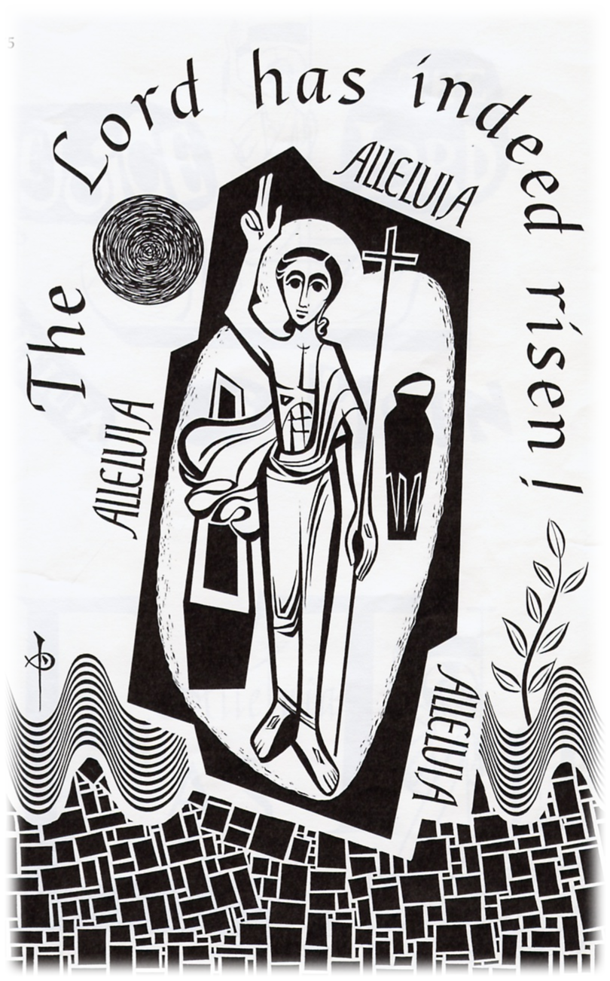  Then Moses summoned Joshua and in the presence of all Israel said to him, ‘Be strong, stand firm, you are going with this people into the land Yahweh swore to their fathers he would give them; you are to give it into their possession. Yahweh himself will lead you; he will be with you, he will not fail you or desert you. Have no fear, do not be disheartened by anything’.  This is the word of the Lord.  4  5
Reading 7  A reading from the prophet Isaiah 25:6-9  On this mountain, the Lord of hosts will prepare for all peoples a banquet of rich food. On this mountain he will remove the mourning veil covering all peoples, and the shroud enwrapping all nations, he will destroy Death for ever.  The Lord will wipe away the tears from every cheek; he will take away his people’s shame everywhere on earth, for the Lord has said so. That day, it will be said: See, this is our God in whom we hoped for salvation; the Lord is the one in whom we hoped. We exult and we rejoice that he has saved us.  This is the word of the Lord.  Reading 8  A reading from the book of Lamentations 3:22-26  The favours of the Lord are not all past, his kindnesses are not exhausted; every morning they are renewed; great is their faithfulness.  ‘My portion is the Lord’ says my soul ‘and so I will hope in him.’ The Lord is good to those who trust him, to the soul that searches for him. It is good to wait in silence for the Lord to save.  This is the word of the Lord.  Reading 9  A reading from the first book Kings 2:1-4  As David’s life drew to its close he laid this charge on his son Solomon, ‘I am going the way of all the earth. Be strong and show yourself a man. Observe the injunctions of the Lord your God, follow his ways and keeping his laws, his commandments, his customs and his decrees, as it stands written in the Law of Moses, that so you may be successful in all you do and undertake, so that Yahweh may fulfil the promise he made me.  This is the word of the Lord.  5 |  | Reading 3  A reading from the letter of St. Paul to the Romans 8:31-35,37-39  With God on our side who can be against us? Since God did not spare his own Son, but gave him up to benefit us all, we may be certain, after such a gift, that he will not refuse us anything he can give. Could anyone accuse those that God has chosen? When God acquits, could anyone condemn? Could Christ Jesus? No! He not only died for us – he rose from the dead, and there at God’s right hand he stands and pleads for us.  Nothing therefore can come between us and the love of Christ, even if we are troubled or worried, or being persecuted, or lacking food or clothes, or being threatened or even attacked. These are the trials through which we triumph, by the power of him who loved us. For I am certain of this: neither death nor life, no angel, no prince, nothing that exists, nothing still to come, not any power, or height or depth, not any created thing, can ever come between us and the love of God made visible in Christ Jesus our Lord.  This is the word of the Lord.  Reading 4  A reading from the letter of St. Paul to the Romans 14:7-12  The life and death of each of us has its influence on others; if we live, we live for the Lord; and if we die, we die for the Lord, so that alive or dead we belong to the Lord. This explains why Christ both died and came to life, it was so that he might be Lord both of the dead and of the living. We shall all have to stand before the judgement seat of God; as scripture says: By my life – it is the Lord who speaks – every knee shall bend before me, and every tongue shall praise God. It is to God, therefore, that each of us must give an account of himself.  This is the word of the Lord.  10
NEW TESTAMENT READINGS  Reading 1  A reading from the letter of St. Paul to the Romans 5:5-11  Hope is not deceptive, because the love of God has been poured into our hearts by the Holy Spirit which has been given us. We were still helpless when at his appointed moment Christ died for sinful men. It is not easy to die even for a good man – though of course for someone really worthy, a man might be prepared to die – but what proves that God loves us is that Christ died for us while we were still sinners. Having died to make us righteous, is it likely that he would now fail to save us from God’s anger? When we were reconciled to God by the death of his Son, we were still enemies; now that we have been reconciled, surely we may count on being saved by the life of his Son? Not merely because we have been reconciled but because we are filled with joyful trust in God, through our Lord Jesus |Christ, through whom we have already gained our reconciliation.  This is the word of the Lord.  Reading 2  A reading from the letter of St. Paul to the Romans 6:3-9  When we were baptised in Christ Jesus we were baptised in his death; in other words, when we were baptised we went into the tomb with him and joined him in death, so that as Christ was raised from the dead by the Father’s glory, we too might live a new life.  If in union with Christ we have imitated his death, we shall also imitate him in his resurrection. We must realise that our former selves have been crucified with him to destroy this sinful body and to free us from the slavery of sin. When a man dies, of course, he has finished with sin. But we believe that having died with Christ we shall return to life with him: Christ, as we know, having been raised from the dead will never die again. Death has no power over him any more.  This is the word of the Lord.  9 |  | Reading 10  A reading from the book of Ecclesiastes 3:2-8  There is a season for everything, a time for every occupation under heaven:  A time for giving birth, a time for dying;  a time for planting, a time for uprooting what has been planted.  A time for building, a time for tearing down.  A time for sorrow, a time for joy.  A time for mourning, a time for dancing.  A time for making love, a time to refrain from love.  A time for finding, a time for losing.  A time for saving, a time for throwing away.  A time for mending, a time for tearing.  A time for keeping silent, a time for speaking.  A time for conflict, a time for peace.  This is the word of the Lord.    6
RESPONSORIAL PSALM  Choose one or one may be sung.  Psalm 1  Response: The Lord is my shepherd, there is nothing I shall want.  The Lord is my shepherd, there is nothing I shall want,  Fresh and green are the pastures where he gives me repose.  Near restful waters he leads me to revive my drooping spirits. ®  He guides me along the right path; he is true to his name.  If I should walk in the valley of darkness no evil would I fear.  You are there with your crook and your staff; with these you give me comfort. ®  You have prepared a banquet for me in the sight of my foes.  My head you have anointed with oil;  My cup is overflowing. ®  Surely goodness and kindness shall follow me all the days of my life.  In Lord’s own house shall I dwell for ever and ever. ®  Psalm 2  Response: The Lord is my light and my help.  The Lord is my light and my help; whom shall I fear?  The Lord is the stronghold of my life; before whom shall I shrink? ®  There is one thing I ask of the Lord, for this I long, to live in the house of the Lord, all the days of my life, to savour the sweetness of the Lord, to behold his temple. ®  O Lord, hear my voice when I call; have mercy and answer. It is your face,  O Lord that I seek; hide not your face ®  I am sure I shall see the Lord’s goodness in the land of the living. Hope in him, hold from and take heart. Hope in the Lord. ®  7 |  | Psalm 3  Response: The Lord is compassion and love.  The Lord is compassion and love,  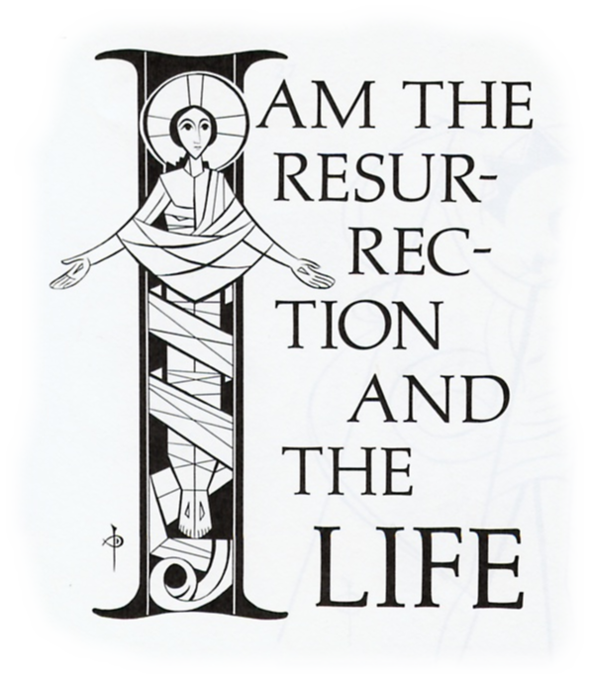  Slow to anger and rich in mercy.  He does not treat us according to our sins  Nor repay us according to our faults. ®  As a father has compassion on his sons,  The Lord has pity on those who fear him;  For he known of what we are made,  He remembers that we are dust. ®  As for man, his days are like grass;  He flowers like the flower of the field;  The wind blows and he is gone  And his place never sees him again. ®  But the love of the Lord is everlasting  Upon those who hold him in fear;  His justice reaches out to children’s children  When they keep his covenant in truth. ®  8

